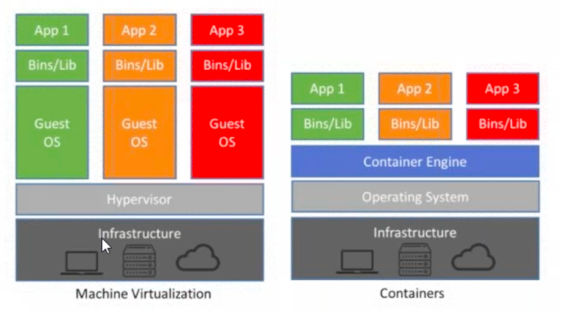
Docker can be installed in 2 types

Local | ACR - azåure container registration
we neet to take care like docker image creation and maintenance | azure will take everything

installation - docker download and install and look for pre requisites 64 bit processor , 4gb ram

bios hardware level should be virtualised( run command system info and see hyper virtualisation is yes)

docker service should be running

this docker installation is to show how to troubleshoot when the pipeline is build in azure devops.
troubleshooting basic commands are
www.dockercommands.com

Container - i) layers of images (linux layer(os) , application layer
ii)mostly linux based images , because small in size
iii)application image on top

in practical environment what ever the build ci cd pipelines are pushed to ACR**

Docker commands

docker —version
docker login
docker ps - to see list of containers
docker ps -a
docker images
docker pull
docker push
docker rm
docker rmi
docker run
docker restart
docker stop
docker kill
docker build
docker commit
docker copy
docker history

try azure labs for docker container - our role is how to push .net build to ACR

DOCKER —HELP

docker file - docker is simple text file to build image

from

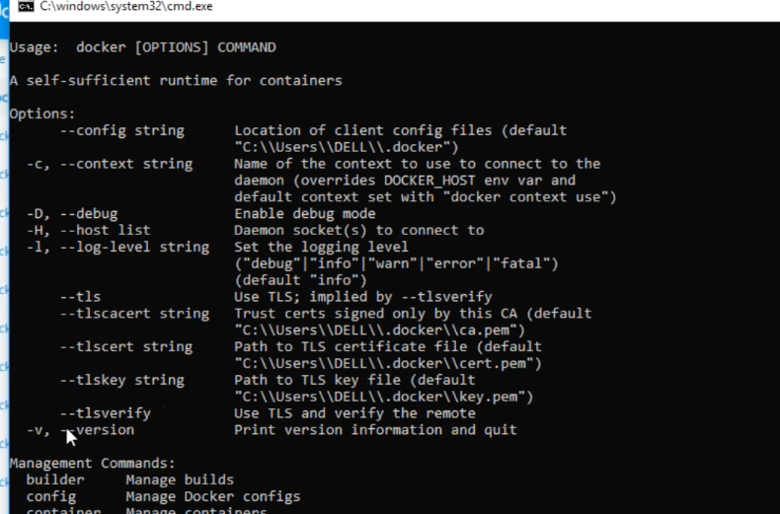
.DOCKETnet core in docker

we need to create docket file which consist of list of cmdlts.

ms build ci cd

1)nugget installer

2)nugget restore

3)ms build

4)unit built cases

5)publish artefacts

STEPS TO DEPLOYING DECOKER WEB APP TO AZURE

container registry in azure - this is known as ACR which stores images data privately

to copy image from ACR to azure devops we need service connection


service connection — azure devops - services - look for docker( if docker is not found go to extension in organisation and install it)

above link has step by step process

https://azuredevopslabs.com/labs/vstsextend/docker/

